Bullet Hell Dungeon

# Overview

Bullet Hell Dungeon is a clone of Enter The Gungeon which is a rogue-like top-down 2D bullet hell game where the player has to shoot his way through multiple levels. The player starts each run in a starting area and then has to find the boss of the level to progress down. Along the way the player will blast enemies and pickup new weapons to use. Play continues until either the player dies or completes each of the levels.

For this DFS project the player will not unlock extras outside of the game, solve puzzles, use keys, disarm traps, or have any special abilities. The player will only be able to run and gun his way through. The enemies will all be simple minded and chase after the player. There will be three levels with difficulty increasing by the weapons the enemies have.

The player will have a small health pool, so they must dodge almost all bullets if they are to continue. The player and enemies will be lacking hands to help with animating

The maps will be relatively simple using rooms made out of tiles. Each room is locked when the player enters until the player kills everyone in the room.

Menus will be navigated with arrow keys and the enter key. Ships are controlled with the arrow keys, space bar, and ctrl key.

|  |  |  |  |
| --- | --- | --- | --- |
| Controls | | | |
| Keyboard/Mouse | | Controller |  |
| W | Left Joystick | | Move Up |
| A | Left Joystick | | Move Left |
| S | Left Joystick | | Move Down |
| D | Left Joystick | | Move Right |
| Mouse | Right Joystick | | Aim |
| Q/E | Y | | Change Weapon |
| Space | B | | Dodge/Roll |
| F |  | | Pickup weapon |
| R |  | | Reload |
| Left Mouse Button | Right Button | | Shoot |

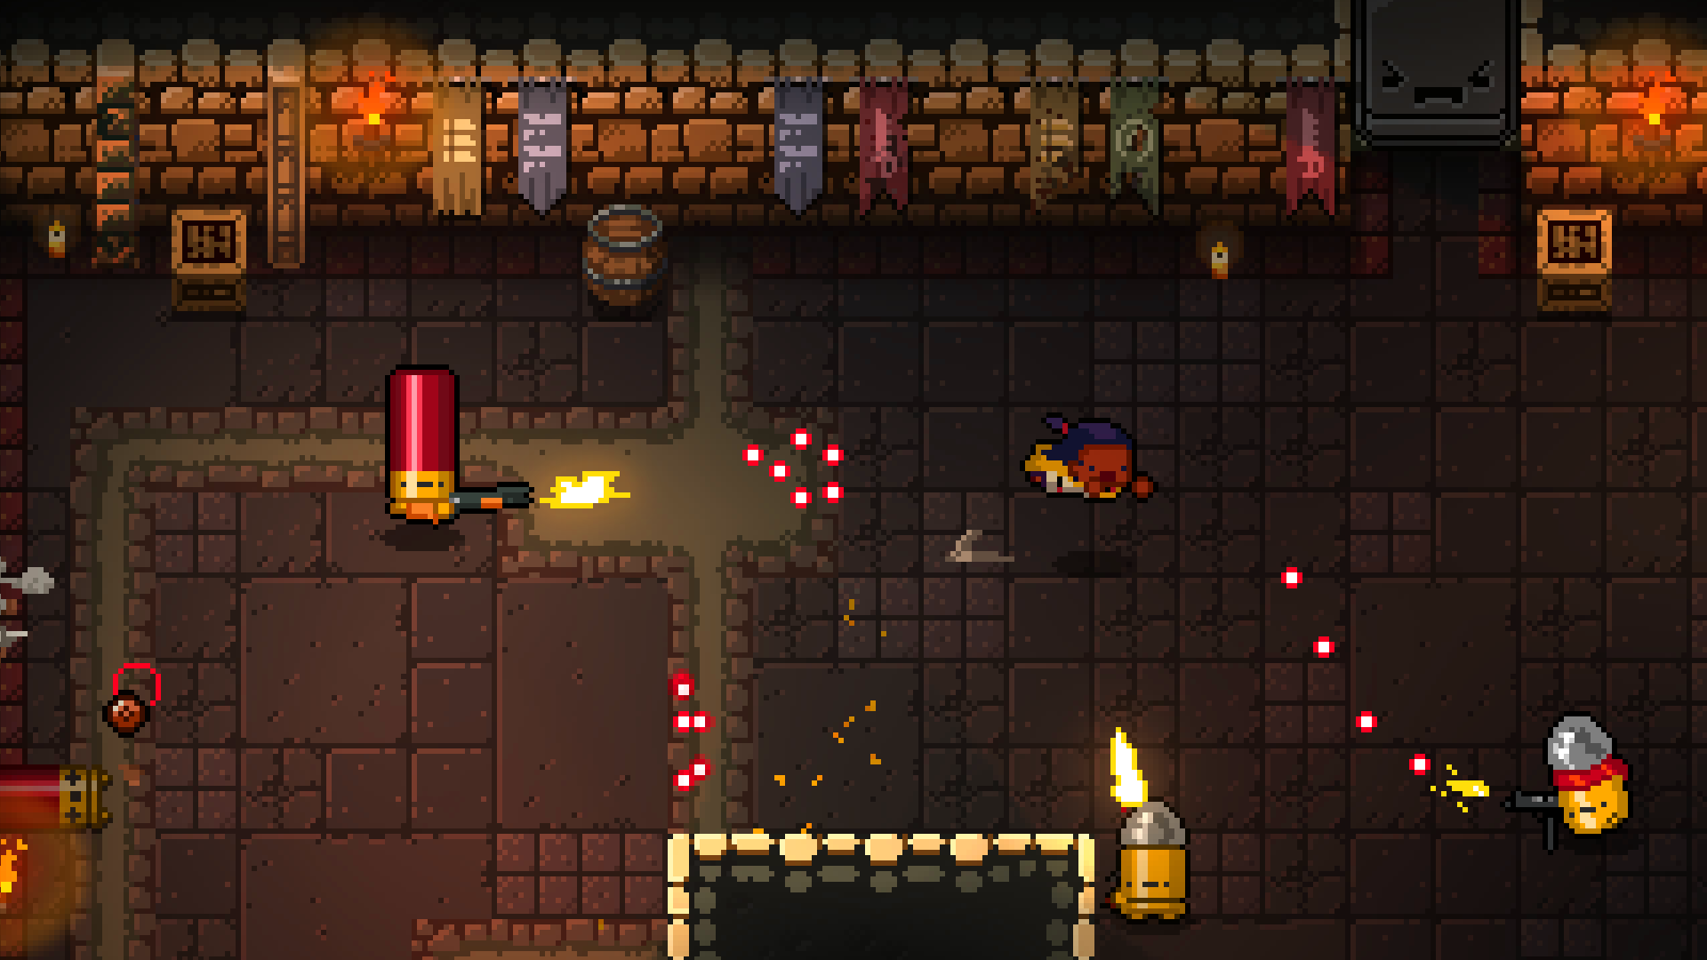

# Milestones

## Milestone 1 06/15/2020

First deliverable with limited game play. The player will be able to walk around a single level and shoot enemies, but the enemies controllers will be extremely basic and will just run at the player no matter what. The focus will be on creating the architecture behind the scenes for the weapons and actors

* Player is created and can walk around in a barren level and can shoot a gun
* Player basic controls are implemented
* Basic weapons and bullets work and enemies can be hit
* Player dies when health reaches 0
* Enemies freeze and stop interacting on death
* Main menu with the Start and quit buttons created.
* Loading screen where assets are loading and White “LOADING” text
* Game over screen saying either "You won" or "You lost" and "Press any key to return to main menu".

Milestone 2  
06/29/2020

The first level can be played completely from start to end

* A map is complete with door locks and enemy spawning
* Enemies will attack the player and attempt to avoid walls
* The first level boss is added
* The player can swap weapons and can pickup weapons dropped from enemies
* There is a pause menu and a HUD
* The player can now dodge bullets

Milestone 3  
07/13/2020

Maps 2 and 3 are finished, AUDIO is added, and menus are finished

* The rest of the weapons are implemented and have sound effects
* The main menu and game now have background music
* Transitions and states for Death, completing a level, and victory are finished
* Maps 2 and 3 are finished and bosses added
* Enemies drop loot (weapons) that the player can pick up
* Loading screen is finished
* Audio controls on pause menu and Options menu are completed

Final Deliverable  
07/21/2020

Final polish and bug fixing.